Final Assessment-Alternative Assessment
Semester | 202520 | Division | CIS
Assessment title in Syllabus | Final_Project_Portfolio | Program | Bachelor of Information Technology/ Bachelor of Information Systems
Course Code | CDS 2413
Course Title | INTRODUCTION TO DATA SCIENCE
Course Instructor |  | CRN
Assessment | Project Deliverable 1 – Data Analysis Report | Submission Date | Week 6
Student Declaration:
Academic Integrity Statement
In accordance with the HCT Academic Integrity Policy
• Students are required to refrain from all forms of academic integrity breaches as defined and explained by HCT.
• A student found guilty of having committed acts of academic integrity breach(es) will be subject to the relevant sanctions as outlined by HCT.
إفادة النزاهة الأكاديمية
وفقًا لسياسة كليات التقنية العليا للنزاهة الأكاديمية
• على الطلبة الإلتزام بلوائح وقواعد النزاهة الأكاديمية، كما هو مبيّن وموضح في السياسات والإجراءات الخاصة بكليات التقنية العليا.
• في حالة ارتكاب الطالب أي شكل من أشكال الإخلال بالنزاهة الأكاديمية، سيتعرض الى العقوبات الموضحة في السياسات ذات الصلة.
This assignment is entirely my/our own work except where I have duly acknowledged other sources in the text and listed those sources at the end of the assignment. I have not previously submitted this work to the HCT, or any other entity. I understand that I may be orally examined on my submission.

Student HCT ID(s):
Student Name(s):
Student Signature
Chatbot (e.g. ChatGPT) statement
This submission allows you to use AI generated tools, but the prompt used must be stated and the response must be in red font. Include References to ChatGPT.

Instructions

Remove instructions and hints from the template before submitting the final report to BBLearn.

CLO1: Introduction and Data Wrangling (5 Points)

Purpose of Data Analysis (1 point)
The purpose of analyzing the (health.xlsx) dataset is to evaluate the healthcare infrastructure in the UAE from 2010 to 2021. By examining the counts of hospitals, beds, and clinics, we can understand the growth trends and the distribution of resources between the Government and Private sectors across different Emirates.

Type of Programming (1 point)
Python is the type of programming used for this data analysis.
- Justification: Python is a leading open-source language for data science because it offers specialized libraries like Pandas for data manipulation (data wrangling), NumPy for numerical analysis, and Matplotlib/Seaborn for advanced data visualization.

Type and Purpose of ML algorithm (1 point)
Type: Supervised Learning (Linear Regression).
Purpose: To predict the future Value (number of facilities/beds) based on theTime period. This helps stakeholders forecast healthcare capacity requirements for upcoming years.

Identify the Varaibles (1 point)
Dependent Variable: Value (The numerical count of facilities or beds).
- Justification: This is the target variable we are measuring and attempting to explain or predict.
Independent Variables: Time period, Reference area, Measure, and Sector.
- Justification: These factors are manipulated or categorized to observe their effect on the Value. For instance, the Sector (Government vs. Private) influences the number of available beds.

Sampling (1 point)
Yes, sampling will be performed to allow for more efficient analysis of specific segments of the population.
- Type of Sampling: Systematic Sampling.
- Justification: Since the data in (health.xlsx) is sorted by year and region, systematic sampling ensures we select data points at regular intervals, providing a balanced representation of the entire 11-year period.

CLO2: Descriptive, Exploratory and Statistical Analysis (10 Points)

Purpose of Descriptive Analysis (1 point)
The purpose is to provide a summarized overview of the dataset's characteristics, such as the average number of clinics per emirate or the variation (spread) in hospital beds between the public and private sectors. It helps identify outliers and provides a baseline for making deeper statistical inferences later.

Script for Descriptive Analysis (1 point)
The following Python function generates descriptive statistics for a specified sample and field:
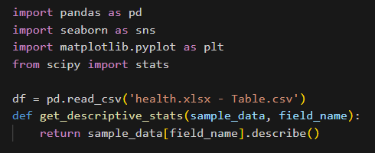

Random Sampling (1 point)
This program extracts a random sample of 150 records and applies the descriptive function to the dependent variable (Value).
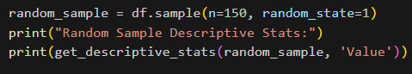

Systematic Sampling (1 point)
This script performs systematic sampling on the dataset filtered for Private sector facilities.
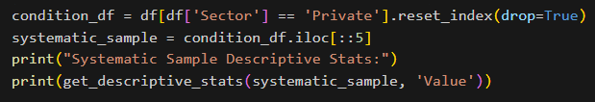

Descriptive Statistical Report (1 point)
Based on the Value field in health.xlsx:
- Mean: 1401.52 (The average resource count per entry).
- Std Dev: 2763.10 (Shows significant variation between small clinics and total bed counts)
- Median: 151.0 (The middle value of the dataset).

Visualisation through Various Charts (2 points)
The dependent variable Value can be visualized using the following code structure:

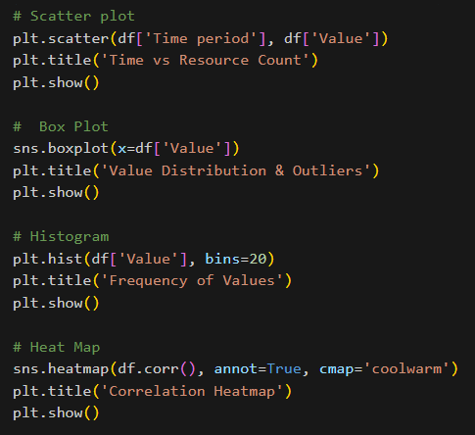

Hypothesis Test (1 point)
To find the correlation between the independent variable (Time period) and the dependent variable (Value):
- Test: Pearson Correlation (r).
- Hypothesis:
H0 (Null): There is no linear relationship between Time and the number of health facilities.
H1 (Alternative): There is a significant positive relationship between Time and the number of facilities.
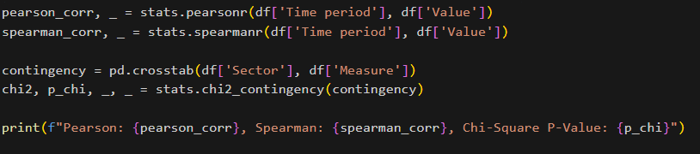

Interpretation: Since the Chi-Square p-value is greater than 0.05 , there is no significant statistical association between the Sector (Private/Gov) and the Measure (Hospitals/Beds/Clinics) in this specific dataset.

One Sample T-test (2 points)
We assess the performance of our random sample (size 150) to see if it is representative of the total population mean of healthcare facilities in the UAE.
Hypothesis:
- H0 (Null): The sample mean is equal to the population mean 1401.52
- H1 (Alternative): The sample mean is significantly different from the population mean.

We test if our random sample is representative of the population mean found in (health.xlsx.)
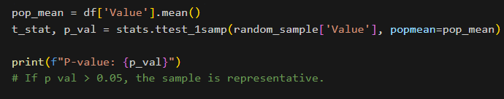

Result & Conclusion:
- Calculated P-Value: 0.8861
- Conclusion: Since the p-value 0.8861 is greater than 0.05, we fail to reject the null hypothesis. This confirms that the random sample we extracted is a statistically accurate representation of the population in (health.xlsx.)

End of Documentation.

References
- Primary Data Source:
Federal Competitiveness and Statistics Centre (FCSC). (2021). UAE Health Facilities 2010-2021. Open Data UAE. Available at: https://bayanat.ae/ (Accessed via health.xlsx).

- gemini.google.com

